**ER Diagram**

ER Model

The ER diagram shows the relationship between the different entity sets. This document describes the different relationships used, participation constraints, ISA relationships and aggregations used. A description of all the tables and the reason for their use is mentioned in the relational model.

**ISA relationships:**

Below is a list of “ISA” relationships we have used:

1. Patron – Student and Faculty

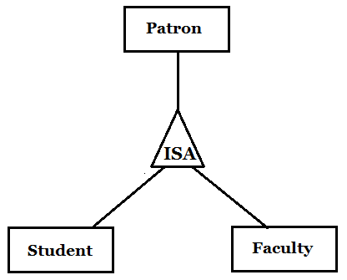

We used the ***ER approach*** to translate the above relationship into tables. Patron table contains the common information and the Student and Faculty table contain information specific to them. This ISA relationship is ***disjoint*** and ***complete***.

1. Resource – Publication, Camera, Room

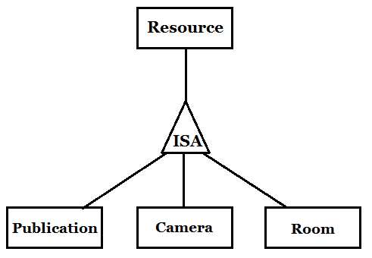

We used the ***ER approach*** to translate the above relationship into tables. Resource table contains a list of the different resources in the system and the individual tables contain information specific to that type of resource. This ISA relationship is ***disjoint*** and ***complete***.

1. Publication – Book, Journal, Conference Paper

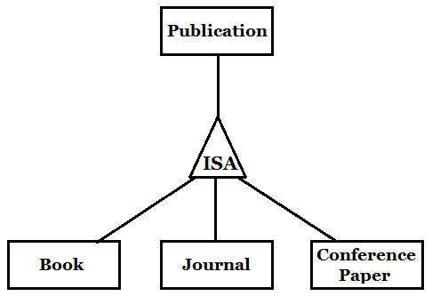

We used the ***Object-oriented approach*** to translate the above relationship into tables. Only individual tables with their respective information is created. No common publications table is created. This ISA relationship is ***disjoint*** and ***complete***.

1. Room – Study, Conference

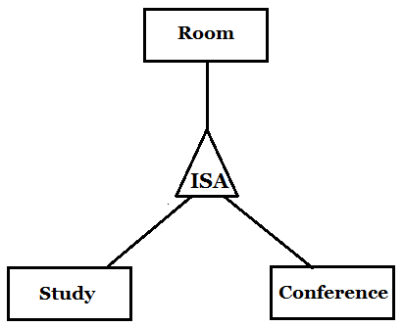

We only created one table for Room and used ***a field in the table*** to specify whether it is a Study or Conference room. This ISA relationship is ***disjoint*** and ***complete***.

**Participation constraints:**

We used three kinds of participation constraints – at most one, at least one and exactly one

***At most one –***

Course (entity) to Teaches (relationship)

A course is taught by at most one faculty

Faculty (entity) to Teaches (relationship)

A faculty teaches at most one course

Reservation (entity) to Estimates Return (relationship)

A reservation estimates return from at most one checkout reference

Reservation (entity) to CalculateLateFee (relationship)

A reservation calculates late fee from at most one late fee reference

Books (entity) to BlockBook (relationship)

A book can be blocked for at most one course by a faculty

***At least one –***

Student (entity) to Enrolled (relationship)

A student must be enrolled in at least one course

***Exactly one –***

Patron (entity) to Belongs to (relationship)

A patron can belong to exactly one department

Student (entity) to Doing (relationship)

A student can be a part of (doing) exactly one program

Course (entity) to Has (relationship)

A course is for exactly one department

Resource (entity) to Present In (relationship)

A resource is present in exactly one library

**Aggregations:**

We used four cases of aggregation – all four have a similar logic. In each case, a patron requests a resource and enters a queue for the resource. Once the reservation is confirmed, that request enters the reservation table.

1. Requests Publication – Enters – Reservation

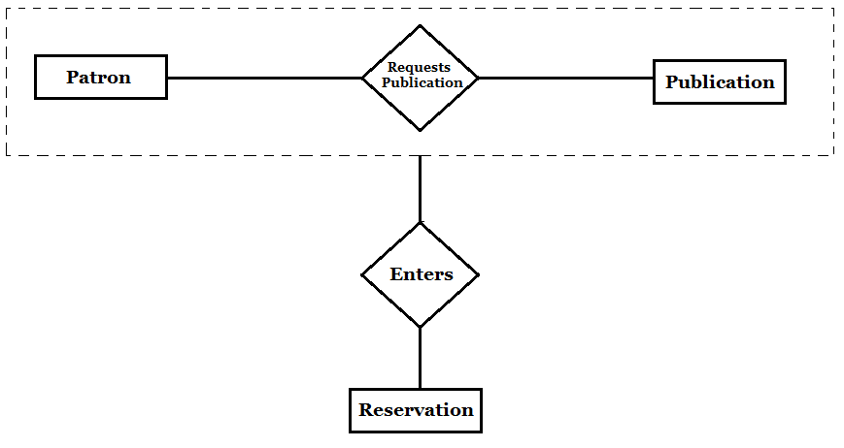

When a patron requests a publication, it enters a queue if that publication has already been checked-out by another patron. Once the reservation is confirmed, the request enters the reservation table.

1. Requests Camera – Enters – Reservation

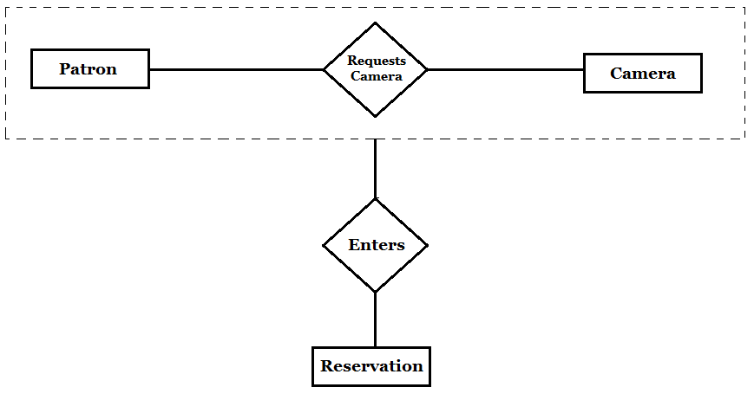

When a patron requests a camera, it enters a queue and the first person in the queue gets the camera at 9am on Friday. When he/she checks out the camera, an entry of the request is made in the reservation table.

1. Requests Room – Enters – Reservation

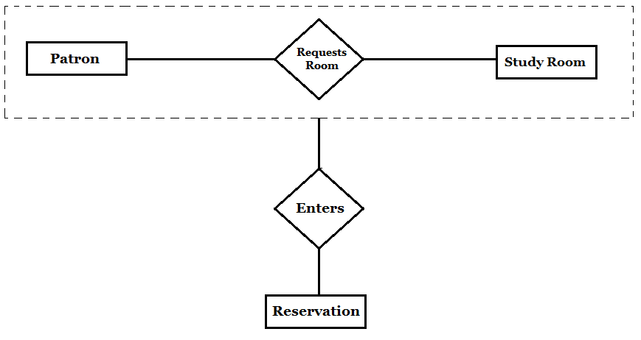

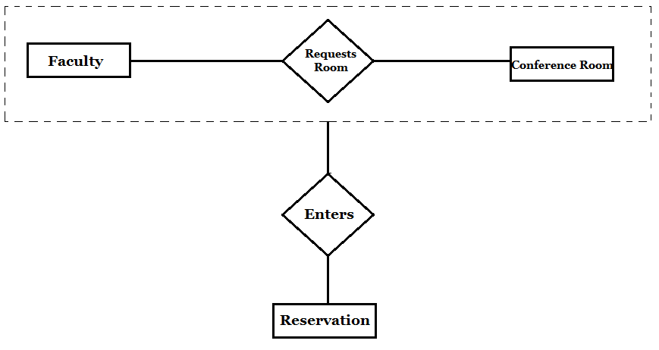

In both the above cases, when a patron requests a room, it enters a separate queue table until the room is checked-out at the time of the reservation. At this point, an entry is made into the reservation table.

**Binary vs Ternary Relationships:**

Most of our relationships are binary. We have used one ternary relationship in our ER diagram between Faculty, Course and Book.

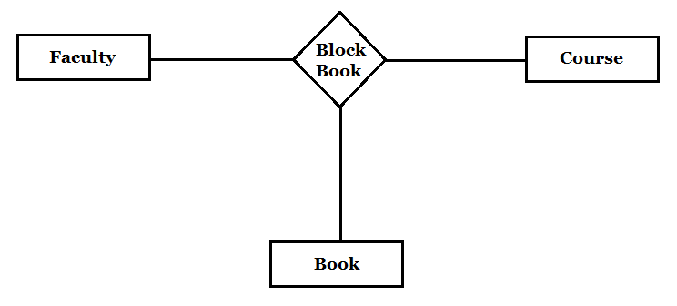

The relationship above shows that a faculty blocks a book for a particular course. This needs to be, and hence has been expressed as a ternary relationship.

**Relational Model**

We tried to maintain 3NF but in some cases 3NF is not satisfied as we knew we would require lots of joins and decided against implementing 3NF.

**1.Patron**- It holds information that is common to both students and faculty including patron id, name of patron, nationality, department id, gender, password.

CONSTRAINTS-

Primary key- patron id,

Foreign key- department_id (dept_id) which references dept_id from the department table

Not null – name , user_id, password (passwd)

unique - user_id

SQL> create table Patron(patron_id varchar(20), name varchar(50) NOT NULL, user_id varchar(20) UNIQUE NOT NULL, nationality varchar(20), dept_id integer, gender varchar(10), passwd varchar(20)NOT NULL, privilege integer default 1, Primary Key(patron_id), Foreign Key(dept_id) references Department(dept_id));

**2.Department**- It holds information about each department including department id, name of department.

CONSTRAINTS-

primary key- department_id

not null - department_name

SQL> create table Department (dept_id integer, dept_name varchar (30) NOT NULL, Primary Key(dept_id));

**3. Student**- It hold information about each student including student number which is same as patron id, phone number, alternate phone number, date of birth.

CONSTRAINTS-

primary key- student_num

foreign key- student_num which references patron_id from patron, the deletion of student_num

from patron will result in the corresponding student_num being deleted from the student table.

not null- phone_num

SQL> create table Student (student_num varchar (20), phone_num varchar(20) NOT NULL, alt_phn_num varchar(20), address varchar(50), dob date, Primary Key(student_num), Foreign Key(student_num) references Patron(patron_id) on delete cascade);

**4.Faculty**- It holds information about each faculty including faculty number which is same as patron id, category id which is the type of faculty ( like Professor , Assistant Professor).

CONSTRAINTS –

primary key- faculty_num

foreign key-

1. faculty_num which references patron_id from Patron table,

2. category_id which references category_id from FacultyCategory, the deletion of category_id from FacultyCategory will result in the corresponding record being set to NULL.

SQL> create table Faculty(faculty_num varchar(20), category_id integer, Primary Key(faculty_num), Foreign Key(faculty_num) references Patron(patron_id), Foreign Key(category_id) references FacultyCategory(category_id) on delete set NULL);

**5. FacultyCategory**- It contains information about the various categories of faculty.

E.g.- Professor, Assistant Professor

CONSTRAINTS

primary key- category_id

not null- faculty type

SQL> create table FacultyCategory (category_id integer, faculty_type varchar (40) NOT NULL, Primary Key(category_id));

**6. Course**- Contains information about what courses belong to what departments and the books that are reserved for a particular course.

CONSTRAINTS

primary key- course_id, dept_id

foreign keys- 1. dept_id in the department table, which when deleted from the department table

will result in the corresponding record in the course table to be also deleted.,

2.book_isbn which references isbn from the book table

SQL>

create table Course (course_id integer, dept_id integer, book_isbn Varchar(20), Primary Key(course_id, dept_id), Foreign Key(dept_id) references Department on delete cascade, Foreign Key(book_isbn) references book(isbn));

**7. Teaches**- It contains information about which faculty teaches which course and the department the faculty belongs to.

CONSTRAINTS

foreign keys-

1. course_id , dept_id from the table course,

2. faculty_num from the faculty table

SQL>create table Teaches (faculty_num varchar(20), course_id integer, dept_id integer, Foreign Key(course_id, dept_id) references Course, Foreign Key(faculty_num) references Faculty);

**8. Program**- Contains information about each program. Degree category has the possible values- undergraduate or graduate. Degree has possible values- MS, BS, Phd.

CONSTRAINTS

primary key- program_id

not null- degree_category, degree

SQL> create table Program (program_id integer, degree_category varchar (20) NOT NULL, degree varchar (30) NOT NULL, Primary Key(program_id));

**9. Doing**- Contains information about what program each student is enrolled in ( program id) as well as the year the student is currently in.

CONSTRAINTS

foreign keys-

1.student_num which references Student,

2.program_id which references program

not null- prog_year

SQL > create table Doing (student_num varchar(20), program_id integer, prog_year varchar(30) NOT NULL, Foreign Key(student_num) references Student, Foreign Key(program_id) references Program);

**10. Enrolled**- Contains information about what course a student is enrolled in , as well as the department to which the particular course belongs to.

CONSTRAINTS

primary key- student_num, course_id, dept_id

foreign keys-

1.student_num references student table, deletion of student_num from the student table will result in the deletion of the corresponding record in the Enrolled table.

2. course_id, dept_id which reference Course table , the deletion of course_id or dept_id from the Course table will result in the deletion of corresponding record in Enrolled table.

SQL> create table Enrolled (student_num varchar(20), course_id integer, dept_id integer, Primary Key(student_num, course_id, dept_id), Foreign Key(student_num) references Student on delete cascade, Foreign Key(course_id, dept_id) references Course on delete cascade);

**11. Resources** – Contains information about the resources that can be borrowed from the library including books, cameras, rooms .

CONSTRAINTS

primary key- resc_id

not null- resc_type

SQL> create table Resources (resc_id varchar (20), resc_type varchar(20) NOT NULL, PRIMARY KEY(resc_id));

**12. Book**- Contains information about books including the isbn , title of the book, name of the author , edition of the book, publisher, year the book was published in and whether or not an e_copy of the book is available or not.

CONSTRAINTS

primary key- isbn

not null- title

SQL> create table Book(isbn varchar(20), title varchar(50) NOT NULL, author_name varchar(40), edition integer, publisher varchar(40), year_of_pub integer, e_copy integer default 0, Primary Key(isbn));

**13. Journal**- Contains information about journals including the issn , title of the journal, name of the author , year the journal was published in and whether or not an e_copy of the journal is available or not.

CONSTRAINTS

primary key- issn

not null – title, author_name , publ_year

SQL > create table Journal (issn varchar (20), title varchar(100) NOT NULL, author_name varchar(40) NOT NULL, publ_year integer NOT NULL, e_copy integer default 0, Primary Key(issn));

**14. Conference** ( conf)- Contains information about each conference including the conference number, name of the conference, name of the author, title of conference paper, year of publication and whether or not an e copy for the conference paper is present or not.

CONSTRAINTS

primary key- conf_num

not null- name_of_conf, author_name, publ_year

SQL> create table Conf (conf_num varchar(20), name_of_conf varchar(30) NOT NULL,author_name varchar(40) NOT NULL, title varchar(200), publ_year integer NOT NULL, e_copy integer default 0, Primary Key(conf_num));

**15. Library**

Contains information about each library including library number, name of the library

CONSTRAINTS

primary key- lib_no

not null- lib_name

SQL> create table Library (lib_no integer, lib_name varchar(30) NOT NULL, Primary Key(lib_no));

**16. BlockBook**- Contains information about the books that have been blocked by faculty, including a unique blocking id, faculty number of the faculty that has blocked the book, the number of books that have been reserved, the department and course the book belongs to and the date till which the book has been blocked.

CONSTRAINTS

primary key- blocking_id

foreign keys- 1.faculty_num which references faculty table , deletion of the faculty_num from

faculty table will result in the corresponding record to be also deleted from the blockbook table.

2.course_id, dept_id references course, deletion of course_id, dept_id from the

course table will result in the corresponding record to be also deleted from the blockbook table.

3. isbn references isbn from book table, deletion of isbn from the

book table will result in the corresponding record to be also deleted from the blockbook table.

not null- reserved_till

SQL> create table BlockBook (blocking_id integer, faculty_num varchar(20), course_id integer, dept_id integer, isbn varchar(20), num_resv integer default 1, reserved_till date NOT NULL, Primary Key(blocking_id),Foreign Key(faculty_num) references Faculty on delete cascade, Foreign Key(course_id, dept_id) references Course on delete cascade, Foreign Key(isbn) references Book(isbn) on delete cascade);

**17. BookList** – contains information about each book ( not just each isbn) , including whether the book is available to the patrons or not.

primary key- book_id

foreign key- 1. isbn references isbn from the book table, deletion of the isbn from the

book table will result in the corresponding record to be also deleted from the booklist table.

2. blocking_id references blocking id from the blockbook table. deletion of the blocking_id from the blockbook table will result in the corresponding record to be also deleted from the booklist table.

3. lib_no references lib_no from the library table

4.book_id references resc_id from the resources table.

SQL> create table BookList(book_id varchar(20), isbn varchar(20), is_available integer default 1, blocking_id integer, lib_no integer, isblocked Number(1) default 0, Primary Key(book_id), Foreign Key(isbn) references Book(isbn) on delete cascade, Foreign Key(blocking_id) references BlockBook(blocking_id), Foreign Key(lib_no) references Library(lib_no), Foreign Key(book_id) references Resources(resc_id));

**18. JournalList** – contains information about each journal ( not just each issn) , including whether the journal is available to the patrons or not

primary key- journal_id ,

foreign keys- 1. issn references issn from the journal table , deletion of the issn from the

journal table will result in the corresponding record to be also deleted from the journallist table.

2. lib_no references lib_no from the library table

3. journal-id references resc_id from the resources table

SQL> create table JournalList(journal_id varchar(20), issn varchar(20), is_available integer default 1, lib_no integer, Primary key(journal_id), Foreign Key(issn) references Journal (issn) on delete cascade, Foreign Key(lib_no) references Library(lib_no), Foreign Key(journal_id) references Resources(resc_id));

**19. CPList** - contains information about each conference paper , including whether the conference paper is available to the patrons or not

primary key- paper_id

foreign keys-

1.conf_num references conf_num from the Conf table, deletion of the conf_num from the conf table will result in the corresponding record to be also deleted from the CPList table.

2. lib_no references lib_no from library table

3. paper_id references resc_id from the resources table.

SQL> create table CPList(paper_id varchar(20), conf_num varchar(20), is_available integer default 1, lib_no integer, Primary key(paper_id), Foreign Key(conf_num) references Conf(conf_num) on delete cascade, Foreign Key(lib_no) references Library(lib_no), Foreign Key(paper_id) references Resources(resc_id));

**20. Reservation**– Contains information about reservations made, by whom they have been made , and what resources have been reserved. isactive takes 2 possible values- 0 indicates that the reservation is no longer active, 1 indicates that it is active.

CONSTRAINTS

primary key- res_id

foreign keys- 1.res_id references resc_id from the resources table

2. patron_id references patron_id from the patron table, deletion of the patron_id from the patron table will result in the corresponding record to be also deleted from the Reservations table.

SQL> create table Reservation (res_id integer, patron_id varchar(20), resc_type varchar(30), resc_id varchar(20), checkout_date date, checkin_date date, due_date date, isactive integer default 1, Primary Key(res_id), Foreign Key(patron_id) references Patron(patron_id) on delete cascade, Foreign Key(resc_id) references Resources(resc_id));

**21. Checkout**- Contains information about the maximum possible amount of time that a patron can borrow a resource for.

CONSTRAINTS

primary key- resc_type, patron_type, is_blocked

not null- duration_hrs

SQL> create table Checkout(resc_type varchar(20), patron_type varchar(1),is_blocked integer, duration_hrs integer NOT NULL, Primary Key(resc_type, patron_type, is_blocked));

**22. CalcLateFees**- This table shows the late fee for each reservation ( if any). The res_id indicates for what resource the late fee has to be payed, late_fee indicates the amount in dollars to be payed, status takes 2 possible values ( 0 indicates patron has not payed the fee and 1 indicates he has).

CONSTRAINTS

primary key- res_id

foreign key- res_id references res_id from the reservations table

not null- late_fee

SQL> create table CalcLateFee(res_id integer, late_fee integer NOT NULL , status integer default 0, Primary Key(res_id), Foreign Key(res_id) references Reservation(res_id));

**23. Camera** – Contains information about each camera including the make, model, camera_id, lens, memory available.

CONSTRAINTS

primary key- camera_id

foreign keys- lib_no references lib_no from the library table

camera_id references resc_id from the resources table.

not null- mek, model, lens, memory_avail

SQL> create table Camera(camera_id varchar(20), make varchar(20) NOT NULL, model varchar(20) NOT NULL, Lens varchar(50) NOT NULL, Memory_avail varchar(10) NOT NULL, lib_no integer, Primary Key(camera_id), Foreign Key(lib_no) references Library(lib_no), Foreign Key(camera_id) references Resources(resc_id));

**24. Room**- Contains information about each room including the room number, type of room, the floor number , capacity of room.

CONSTRAINTS

primary key- room_no

foreign keys-

1. lib_no references lib_no from the library table.

2. room_no references resc_id from the resources table.

not null- capacity, room_type

SQL > create table Room(room_no varchar(20), room_type varchar(20) NOT NULL,floorno integer, capacity integer NOT NULL, lib_no integer, Foreign Key(lib_no) references Library(lib_no) on delete cascade, Primary Key(room_no), Foreign Key(room_no) references Resources(resc_id));

**25. Resv_camera_q** – Contains information about the patrons that are currently in the queue for a particular camera , as well as their position in the queue.

CONSTRAINTS

primary key- patron_id, camera_id, intended_Friday

foreign key –

1. patron_id references patron-id from the patron table, deletion of the patron_id from the

patron table will result in the corresponding record to be also deleted from the resv_camera_q table.

2. camera_id references camera_id from the camera table , deletion of the camera_id from the

camera table will result in the corresponding record to be also deleted from the resv_camera_q table.

SQL> create table resv_camera_q(camera_id varchar(20), patron_id varchar(20), intended_friday date, que_pos integer, Primary Key(patron_id, camera_id, intended_friday), Foreign Key(patron_id) references Patron(patron_id) on delete cascade, Foreign Key(camera_id) references Camera(camera_id) on delete cascade);

**26. Resv_publ_q** –Contains information about the patrons that are currently in the queue for a particular publication ( books, journals and conference papers) , as well as their position in the queue.

CONSTRAINTS-

primary key- publ_no, patron_id

foreign keys-

1. patron_id references patron_id from the patron table, deletion of the patron_id from the

patron table will result in the corresponding record to be also deleted from the resv_publ_q table.

2. publ_no references resc_id from the resources table.

SQL >create table resv_publ_q(publ_no varchar(20), patron_id varchar(20), req_date date, Primary Key(publ_no, patron_id), Foreign Key(patron_id) references Patron(patron_id) on delete cascade, Foreign Key(publ_no) references Resources(resc_id));

**27. Resv_room**- Contains information about the reservations made on rooms including the room number, intended check out time as start_time , intended check in time as end_time. is_active takes 3 possible values- 0 indicates the reservation is no longer active but has been used, 1 indicates the room is currently occupied, 2 indicates the reservation is not active and has been cancelled as the patron did not turn up.

CONSTRAINTS

primary key- room_no,start_time,end_time,is_active

foreign keys-

1 .patron_id references patron_id from the patron table, deletion of the patron_id from the

patron table will result in the corresponding record to be also deleted from the resv_room table.

2. room_no references room_no from the room table, deletion of the room_no from the

room table will result in the corresponding record to be also deleted from the resv_room table.

not null- start_time, end_time

not null- start_time, end_time

SQL > create table resv_room(room_no varchar(20), patron_id varchar(20), start_time date NOT NULL, end_time date NOT NULL, is_active Number(1) default 1, Primary Key(room_no,start_time,end_time,is_active), Foreign Key(patron_id) references Patron(patron_id) on delete cascade, Foreign Key(room_no) references Room(room_no) on delete cascade);

**28 . The reservation_seq** is for entering a reservation number into the reservation table

Create sequence reservation_seq

start with 1 increment by 1;

**29. The blocking_seq** is for entering blocking_id into the blockbook table.

CREATE SEQUENCE blocking_seq

START WITH 1

INCREMENT BY 1

NOCACHE

NOCYCLE;

**30. Notifications** – Contains information about the notifications that are sent to patrons.

primary key- patron_id, message

foreign key- patron_id references patron_id from the patron table, deletion of the patron_id from the patron table will result in the corresponding record to be also deleted from the notifications table

SQL>

Create table notifications

(Patron_id Varchar(20),

Message Varchar2(2000),

Foreign Key(patron_id) references Patron(patron_id) on delete cascade,

primary key (Patron_id,Message));

**31. PROCEDURE : Account_deactivateprocedure**

This procedure checks if a patron has status=1 in the calclate fee table ( i.e the patron has not paid the late fee) and if the current date is 90 days past the due_date for the particular resource by that particular patron. If yes, it sets the privilege to 0 – which means the account has been deactivated.

SQL>

Create or replace

procedure Account_deactivate (p_id IN VARCHAR2,

p_out OUT VARCHAR2)

is

counter NUMBER;

BEGIN

select count(*)

into counter

from reservation r

where sysdate - r.due_date > 90

and r.patron_id = p_id

and not exists (select *

from calclatefee cl

where cl.res_id = r.res_id

and cl.status = 1

);

if counter > 0 then

Update patron p

set privilege = 0

where p.patron_id = p_id;

p_out := 'deactivate';

else

p_out := 'nochange';

end if;

END;

/

**32. PROCEDURE : Roomy**

This Procedure checks if a patron who has reserved a room has checked out or not. If a patron has not checked out an hour after the start time, the reservation is cancelled by setting the is_active column to 0.

SQL>

CREATE OR REPLACE PROCEDURE roomy

AS

BEGIN

update resv_room

set is_active=0

where is_active=1 AND (24*(sysdate-start_time)) >=1;

EXCEPTION

WHEN OTHERS THEN

NULL;

END;

/

**33. PROCEDURE: roomy2**

This procedure sets the isactive flag to 0 in the reservation table ( indicating that reservation is no longer active) when the current time is past the check in time.

CREATE OR REPLACE PROCEDURE roomy2

AS

BEGIN

update reservation set isactive=0 , checkin_date =due_date

where isactive=1 AND  resc_type='Room' AND (24*(sysdate-due_date)) >0;

END;

/

**34. PROCEDURE: notify_camera**

This procedure checks if the camera(s) that have been requested ( i.e present in the resv_camera_q ) have been returned or not ( i.e if the isactive is 1 in reservation then the camera has not been returned).

If they have not been returned then the request in the resv_camera_q for that camera is cancelled and a message is sent to the concerned patron.

If they have been returned then a message is sent to the 1st patron in the resv_camera_q for a particular camera, that it is available for pickup.

SQL>

CREATE OR REPLACE PROCEDURE notify_camera

AS

cursor pats1 is

SELECT camera_id,patron_id,intended_friday

FROM resv_camera_q

WHERE que_pos=1 AND intended_friday =(SELECT sysdate from dual)

AND camera_id IN(SELECT resc_id

FROM Reservation

WHERE resc_type= 'Camera' AND isactive=1);

cursor pats2 is

SELECT camera_id, patron_id FROM resv_camera_q

WHERE que_pos=1 AND to_date(intended_friday) = to_date(sysdate) -- '13-NOV-15'

AND camera_id IN(SELECT resc_id

FROM Reservation

WHERE resc_type= 'Camera' AND isactive=0);

pats_id1 resv_camera_q.patron_id%type;

pats_id2 resv_camera_q.patron_id%type;

cam_id resv_camera_q.camera_id%type;

cam_id2 resv_camera_q.camera_id%type;

int_fri resv_camera_q.intended_friday%type;

BEGIN

OPEN pats1;

LOOP

FETCH pats1 into cam_id,pats_id1,int_fri;

EXIT WHEN pats1%notfound;

dbms_output.put_line('Camera ' || cam_id || 'has not been returned. Reservation cancelled'); /* message to be sent to pats_id1 */

Insert into notifications

values(pats_id1, 'Camera ' || cam_id || 'has not been returned. Reservation cancelled');

DELETE FROM resv_camera_q

WHERE camera_id = cam_id

AND intended_friday = int_fri; /* deleting records in queue for camera(s) that have not been returned by fri 8am */

commit;

END LOOP;

CLOSE pats1;

OPEN pats2;

LOOP

FETCH pats2 into cam_id2,pats_id2;

EXIT WHEN pats2%notfound;

dbms_output.put_line('Camera' || cam_id2 || 'available for checkout. please collect it before 10 am');

Insert into notifications

values(pats_id2, 'Camera' || cam_id2 || 'available for checkout. please collect it before 10 am');

commit;

END LOOP;

CLOSE pats2;

EXCEPTION

WHEN OTHERS THEN

NULL;

END;

/

**35. PROCEDURE- notify_camera2**

This procedure runs at Friday 10AM. It checks if a record with que_pos=1 exists in the resv_camera_q ( A record only exists at this time if a patron has not checked out the requested camera).

So the request for the camera is cancelled for that patron and a message is sent to the concerned patron and the record is deleted from the resv_camera_q. The queue positions for a request made for that camera are decremented by 1.

SQL>

CREATE OR REPLACE PROCEDURE notify_camera2

AS

cursor pats3 is

SELECT patron_id,camera_id,intended_friday FROM resv_camera_q

WHERE que_pos=1 AND to_date(intended_friday)= to_date( sysdate); --'13-NOV-15';

pats_id3 resv_camera_q.patron_id%type;

cam_id3 resv_camera_q.camera_id%type;

int_fri3 resv_camera_q.intended_friday%type;

BEGIN

OPEN pats3;

LOOP

FETCH pats3 into pats_id3,cam_id3,int_fri3;

EXIT WHEN pats3%notfound;

dbms_output.put_line('You have not checked out the reserved camera '|| cam_id3 || ' Reservation cancelled');

Insert into notifications

values(pats_id3,'You have not checked out the reserved camera '|| cam_id3 || ' Reservation cancelled');

UPDATE resv_camera_q

SET que_pos = que_pos-1

WHERE camera_id = cam_id3

AND intended_friday=int_fri3;

DELETE FROM resv_camera_q

WHERE camera_id=cam_id3 AND que_pos=0 AND intended_friday=int_fri3;

commit;

END LOOP;

CLOSE pats3;

--EXCEPTION

--WHEN OTHERS THEN

--NULL;

END;

/

**36. PROCEDURE: notify_camera3**

This procedure runs immediately after notify_camera2. It sends notifications to the patrons whose position in the queue has been updated to 1 as a result of notify_camera2.

SQL>

CREATE OR REPLACE PROCEDURE notify_camera3 /* Runs immediately after procedure notify_camera2 */

AS

cursor pats4 is

SELECT patron_id,camera_id,intended_friday FROM resv_camera_q

WHERE que_pos=1 AND to_date(intended_friday)= to_date( sysdate );

pats_id4 resv_camera_q.patron_id%type;

cam_id4 resv_camera_q.camera_id%type;

int_fri4 resv_camera_q.intended_friday%type;

BEGIN

OPEN pats4;

LOOP

FETCH pats4 into pats_id4,cam_id4,int_fri4;

EXIT WHEN pats4%notfound;

dbms_output.put_line('Camera '|| cam_id4 || ' is available for pickup');

where que_pos=1, camera_id= cam_id4, and intended_friday = int_fri4

Insert into notifications

values (pats_id4,'Camera '|| cam_id4 || ' is available for pickup');

commit;

END LOOP;

CLOSE pats4;

--EXCEPTION

--WHEN OTHERS THEN

--NULL;

END;

/

**37. PROCEDURE: notify_books**

This procedure sends notifications (reminders to concerned patrons when they have checked out a book and their reservation is due in 1 or 3 days.

It also sends reminders when a patron has not returned a book and the current date is either 30 ,60 or 90 days past the due date of that particular book.

CREATE OR REPLACE PROCEDURE notify_books

AS

cursor d_date is

SELECT due_date,patron_id FROM Reservation

WHERE resc_type='Book';

du_date Reservation.due_date%type;

p_id Reservation.patron_id%type;

today date;

today1 number;

today2 number;

BEGIN

SELECT sysdate into today from dual;

OPEN d_date;

LOOP

FETCH d_date into du_date,p_id;

EXIT WHEN d_date%notfound;

today1 := ceil(du_date-today) ;

today2 := ceil(today- du_date) ;

dbms_output.put_line( today1 );

IF (today1 = 3 )

THEN dbms_output.put_line(' The due date for your book is in 3 days');

Insert into notifications

values(p_id, ' The due date for your book is in 3 days');

ELSIF ( today1 = 1 )

THEN dbms_output.put_line(' The due date for your book is in 1 day');

Insert into notifications

values(p_id, ' The due date for your book is in 1 day');

ELSIF ( today2 = 30 )

THEN dbms_output.put_line(' The borrowed book was due 30 days ago.Please return the borrowed item and pay the late fee');

Insert into notifications

values(p_id, ' The borrowed book was due 30 days ago.Please return the borrowed item and pay the late fee');

ELSIF ( today2 = 60 )

THEN dbms_output.put_line(' The borrowed book was due 60 days ago.Please return the borrowed item and pay the late fee');

Insert into notifications

values(p_id, ' The borrowed book was due 60 days ago.Please return the borrowed item and pay the late fee');

ELSIF ( today2 = 90 )

THEN dbms_output.put_line(' The borrowed book was due 90 days ago.Please return the borrowed item and pay the late fee to avoid suspension of library privileges.');

Insert into notifications

values(p_id, ' The borrowed book was due 90 days ago.Please return the borrowed item and pay the late fee to avoid suspension of library privileges.');

END IF;

commit;

END LOOP;

CLOSE d_date;

EXCEPTION

WHEN OTHERS THEN

NULL;

END;

/

**38. PROCEDURE: checkreserve**

This procedure sets the isblocked flag in the booklist table to 0 ( indicating it is no longer blocked by the faculty) when the current date is past the reservation date ( reserved_till) .

CREATE OR REPLACE PROCEDURE checkreserve

AS

BEGIN

update booklist

set isblocked=0

where book_id in ( select bo.book_id from booklist bo, blockbook bl where bo.isblocked=1 and bo.blocking_id=bl.blocking_id and to_date(bl.reserved_till) <= to_date(sysdate));

END;

/

**39**. **TRIGGER: CalculateLateFee**

This trigger is used to calculate the late fee for a resource. After a patron has checked in a resource , the trigger checks if the checked in date is after the due date for the resource. If yes, the late fee is calculated based on the type of resource borrowed and whether or not a book has been blocked .

The late fee rates are fetched from the LateFeeReference table.

SQL>

CREATE OR REPLACE TRIGGER CalculateLateFee

AFTER UPDATE

OF Checkin_date ON Reservation

FOR EACH ROW

WHEN (NEW.Resc_type IN ('Book','Journal','Conf','Camera') AND NEW.Checkin_date > NEW.Due_date)

DECLARE

v_unit varchar2(30);

n_apu number;

n_diff number;

n_amount number;

BEGIN

-- fetch unit and amount per unit from reference table

SELECT Unit, Amt_per_unit INTO v_unit, n_apu FROM LateFeeReference WHERE Resc_type = :NEW.Resc_type;

IF v_unit = 'Day' THEN

n_diff := :NEW.Checkin_date - :NEW.Due_date;

--dbms_out.put_line(:n_diff);

END IF;

IF v_unit = 'Hour' THEN

n_diff := (:NEW.Checkin_date - :NEW.Due_date)*24 + 1;

--dbms_out.put_line(:n_diff);

END IF;

n_amount := n_diff * n_apu;

INSERT INTO CalcLateFee VALUES (:NEW.Res_id, n_amount, 0);

END;

/

**40. TRIGGER: CalculateDueDate**

This trigger is used to calculate the due date of all resources except rooms. The due date is calculated based on the type of patron( faculty or student) , type of resource , and for a book whether or not it has been blocked by a faculty.

CREATE OR REPLACE TRIGGER CalculateDueDate

BEFORE INSERT

ON Reservation

FOR EACH ROW

WHEN (NEW.Resc_type IN ('Book','Journal','Conf','Camera'))

DECLARE

duration number;

cam_date varchar2(20);

p_type varchar2(3);

BEGIN

SELECT SUBSTR(:NEW.Patron_id,1,1) INTO p_type FROM Dual;

--dbms_output.put_line(p_type);

IF :NEW.Resc_type = 'Book' THEN

SELECT Duration_Hrs INTO duration FROM CheckOut WHERE Resc_type = :NEW.Resc_type AND Patron_type = p_type AND Is_blocked = (SELECT IsBlocked FROM BookList WHERE Book_id = :NEW.Resc_id);

--dbms_output.put_line(duration);

:NEW.Due_date := :NEW.Checkout_date + (duration/24);

ELSIF :NEW.Resc_type = 'Camera' THEN

SELECT TO_CHAR(:NEW.Checkout_date+6,'YYYY/MM/DD')||' 18:00:00' INTO cam_date FROM DUAL;

--dbms_output.put_line(cam_date);

:NEW.Due_date := TO_DATE(cam_date, 'YYYY/MM/DD HH24:MI:SS');

ELSE

SELECT Duration_Hrs INTO duration FROM CheckOut WHERE Resc_type = :NEW.Resc_type AND Patron_type = p_type;

--dbms_output.put_line(duration);

:NEW.Due_date := :NEW.Checkout_date + (duration/24);

END IF;

END;

/

**Constraints**

1. **Some combinations should clearly not be allowed e.g. an undergraduate in a Ph.D degree program.**

We have stored a list of all possible valid combinations in a table called Program. For any new student, only these combinations will be shown in the drop down while entering the details.

1. **Restricting course reserved materials to only appropriate students**.

We are handling this by showing only the list of books that the student is allowed to request when he goes to the publication module. The data is fetched by joining a few table:

Enrolled, Course, BlockBook, Student

1. **Book may be reserved for a course by a faculty member for a period up till 4 months.** We have created a separated module which is accessible only by faculty in which the faculty can block books for the course he/she teaches. Course table has a list of books assigned to each course, so only those books are shown to the faculty.
2. **Reserved books can be checked out for maximum of 4hrs and by only students of the class for which the book is reserved.**

Firstly the student is able to view only books which are restricted by its enrollment, as mentioned above. The checkout duration is actually calculated by looking up a table called Checkout, which has a list of check out durations in various scenarios. The calculation of due time/date is done by a **trigger** which is triggered each time an entry is made in the reservation table.

1. **Calculation of all due dates for all resources.**

The checkout duration is actually calculated by looking up a table called Checkout, which has a list of check out durations in various scenarios. The calculation of due time/date is done by a **trigger** which is triggered each time an entry is made in the reservation table.

1. **Waitlist for the resources.**

We have created separate tables for each type of resources which maintains the waitlist and clears the waitlist as and when needed.

1. **Faculty always have priority on the wait queue of publications.**

We maintain all patrons in the same waitlist queue, but before clearing any student’s waitlist, we check if there is a faculty in the same queue. If there is a faculty we send the notification to the faculty.

1. **Late Fee**

We have two tables, lateFeeReference and CalcLateFee. lateFeeReference stores the late fee calculation rules for each of the resources. CalcLateFee stores the actual calculated late fee against each reservation. Late fee gets calculated only when a patron returns the resources after comparing the check-in date and the duedate. All these late fee calculations are done using a **trigger**. As soon as there is an update in the reservation table with a checkin date the **trigger** runs and makes an entry in the CalcLateFee table in case there is a late fee applicable.

1. **Due date reminders**

We have created a **procedure** to generate all notifications related to upcoming duedates.

1. **Late fee reminders**

We have created a **procedure** to generate all late fee reminders.

1. **Account deactivation**

We have created a **procedure** to check all the patrons who have not cleared their dues for more than 90 days and this proc itself deactivated their account.

1. **A conference room can be booked only by faculty while a study room can be booked by both student and faculty.**

We do not allow such a request at the interface itself.

1. **If patron is not authorized for room type, an error message is presented.**

We do not allow such a request at the interface itself.

1. **If a room is not “checked out” by 1 hour after reserved start time, the reservation is automatically cancelled.**

We have created a **procedure** for the same.

1. **Camera reservation confirmation**

We have created a **procedure** which runs on every Friday and checks if the requested camera is returned and the first person in the queue gets a notification.

If the camera is not returned, then the reservations for the camera are cancelled by the procedure and the patron at que pos 1 is informed.

1. **If a patron fails to checkout the camera by 10am**.

We have created a **procedure** for the same. If the camera is not checked out by 10am, then the second person in the queue get the notification to collect the camera and the first person gets a notification that his/her reservation is canned.

**SQL Queries and snapshots**

--1. This query returns the patron names (desc order) along with the no. of times they have failed to return a resource on time between 5th oct and 5th nov

select count(r.res_id), p.name

from reservation r, patron p

where r.due_date >= '05-OCT-2015'

and r.due_date <= '05-NOV-2015'

and r.resc_type <> 'Room'

and r.patron_id = p.patron_id

and ((r.isactive = 1 and r.due_date < sysdate) or (r.isactive = 0 and r.checkin_date > r.due_date))

group by p.patron_id, p.name

order by p.name desc;

--We are taking all those reservations in consideration for which either the resource is not returned till date or for which the resource was returned after due date.

Output:

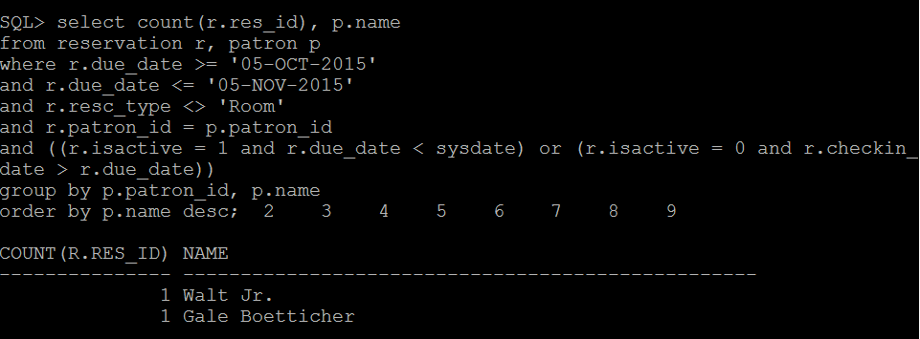

--2. This gives the count of all rooms which were rendered null and void because the patron did not checkout.

select count(*)

from resv_room r

where r.is_active = 0

and r.start_time >= '30-OCT-2015'

and r.start_time <= '06-NOV-2015';

-- Below is the description of how our table "resv_room" stores the data

-- is_active = 0 : null void ; is_active = 1: active reservation waiting for checkout ; is_active = 2: checked out

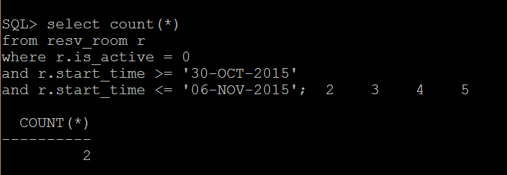

--3. This gives the sum of the late fee that was actually collected by the library between 5th oct and 5th Nov

select sum(late_fee)

from CalcLateFee cl, reservation rsv

where cl.status = 1

and cl.res_id = rsv.res_id

and rsv.checkin_date >= '05-OCT-2015'

and rsv.checkin_date <= '05-NOV-2015';

-- Entries get inserted in our "calclatefee" table only if the resource has been returned after the due date. The status column checks if the late fee was paid or unpaid.

Output:

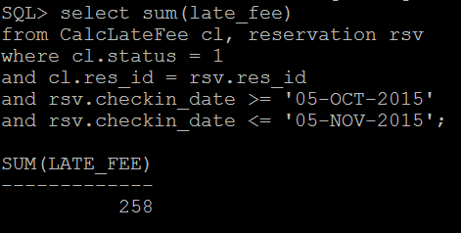

--4. This gives the capacity of the room which is maximum in demand based on the reservations made between 5th oct and 5th nov

select temp.rm

from (select r.capacity rm, count(*) ct

from resv_room rsv, room r

where rsv.room_no = r.room_no

and rsv.start_time >= '05-OCT-2015'

and rsv.start_time <= '05-NOV-2015'

group by r.capacity ) temp

where temp.ct = (select max(temp1.ct) from (select r.capacity rm, count(*) ct

from resv_room rsv, room r

where rsv.room_no = r.room_no

and rsv.start_time >= '05-OCT-2015'

and rsv.start_time <= '05-NOV-2015'

group by r.capacity) temp1) ;

-- room table has a list of all rooms in the library, resv_table has a list of all requests made to reserve any room.

